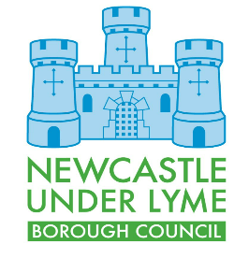 |  | First Draft Local Plan  Comments Form |  |  |  |  |  |  | Ref: (For official use only)
Please return to Newcastle-under-Lyme Borough Council by 14/08/2023
Privacy notice available on Newcastle-under-Lyme website - https://www.newcastle-staffs.gov.uk/privacy-notices/planning-policy-privacy-notice
This form has two parts –
Part A – Personal Details: need only be completed once.
Part B – Your comments (s). Please fill in a separate sheet for each comment you wish to make.

You can submit this form via e-mail to planningpolicy@newcastle-staffs.gov.uk or post it to us at Planning Policy, Newcastle-under-Lyme Borough Council, Castle House, Barracks Road, Newcastle-under-Lyme, ST5 1BL

Part A

1. Personal Details |  |  |  |  |  |  |  | 2. Agent’s Details (if applicable)
*If an agent is appointed, please complete only the Title, Name and Organisation (if applicable)
boxes below but complete the full contact details of the agent in 2.

Title
First Name
Last Name
Job Title
(where relevant)
Organisation
(where relevant)
Address Line 1
Line 2
Line 3
Line 4
Post Code
Telephone Number
E-mail Address
(where relevant)
 | Part B – Please use a separate sheet for each Comment
 | Name or Organisation:
3.Which document does your comment relate: Draft Local Plan / Sustainability Appraisal / Habitats Regulations Assessment (delete as appropriate)

4.To which part of document does your comment relate?

Paragraph | Policy | Policies Map

5. What is the nature of your comment?

- General Comment

- Support

- Objection

Please tick as appropriate
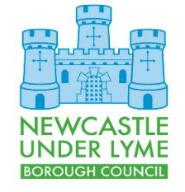
6. Please provide your comment below: Additional sheets can be added if required

